Apps
Unlike on other operating systems, in TROM-Jaro you can find all of your applications in one single place. No need to search the web, no need to use the Terminal.

Repositories
In TROM-Jaro you have two main sources where the software comes from: repositories and AUR.
The repositories contain software that is tested on Manjaro, and AUR only has software that is tested on Arch (what Manjaro is built upon) – however pretty much all the AUR software works on Manjaro (thus TROM-Jaro).
Mind you, not all the applications in “Add/Remove Software” are trade-free. To install trade-free applications go to our APPS page.

Add/Remove Software
In “Add/Remove Software” simply search for the name of the app you want to install. Once found, select for install and Apply.
You will see a popup showing you exactly what will be installed on your system – simply click “Commit”, add your password, and the installation will proceed. Search, Select, Apply, Commit.
To uninstall do the same, select the installed application and “Apply”.
If you are curious to see the “behind the scenes” processes when installing or uninstalling any applications, click “Details”. Alternatively you can simply browse applications by categories or groups.

Manjaro App Center
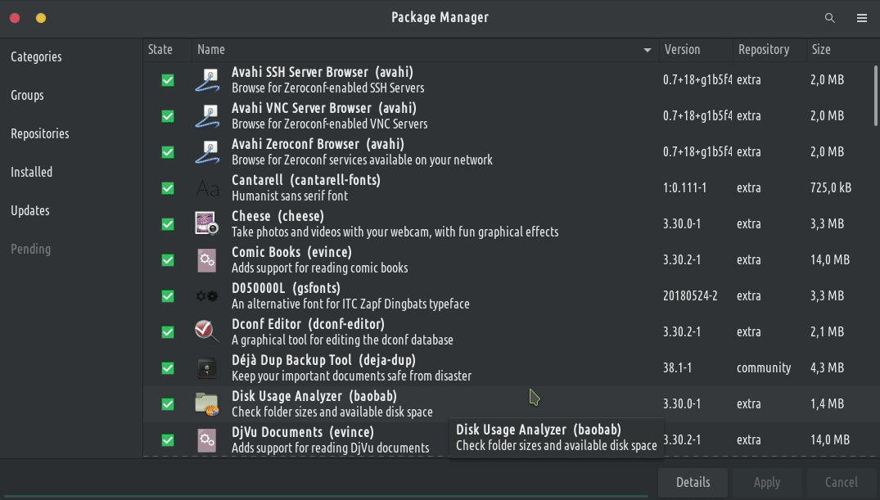

Do you want more apps?
Recommended Software (Cross-Platform Software for Linux, MacOS and Windows):
- activitypub
- ActivityPub Apps
- Android Apps
- AppImage
- Chaotic AUR Package Name and Summary
- Command Line Apps
- dfrn
- diaspora
- Discover Manjaro Apps
- Distributed Computing
- EDU
- Electron Apps
- Fediverse
- Flatpak
- Homebrew
- inbound
- latest trade-free apps
- litepub
- matrix
- microformats
- micropub
- Moonmoon
- ostatus
- outbound
- PHP-Proxy
- removed from the trade-free apps
- RSS-Bridge
- searX
- self-hosted
- smtp
- TiddlyWiki
- Trade-Free Apps
- trade-free apps in Chaotic AUR
- TROMjaro Apps
- Web Apps
- webmention
- websub
- xmpp
- YunoHost Apps
- Zero Install
- zot
- βTorrent

Local apps
Linux App Finder: All Applications
Linux Softpedia: Get Education Software, Get Science and Engineering Software
Sourceforge: Browse Open Source Software for Linux (recently updated)
AlternativeTo: Open Source Apps for Linux

Portable apps
Sometimes also called standalone, is a program designed to read and write its configuration settings into an accessible folder in the computer, usually in the folder where the portable application can be found. This makes it easier to transfer the program with the user's preferences and data between different computers. A program that doesn't have any configuration options can also be a portable application.
Portable Linux Apps: Applications for Linux that you can carry around !
Top Linux Apps: Portable Apps & Games for GNU Linux !
Portable Games for Linux: Packages

Java platform
These are software applications that run on the Java platform or are programmed in Java language.
Wikipedia: Category:Java platform software
Sourceforge: Education Software

Web based
A client–server computer program that the client (including the user interface and client-side logic) runs in a web browser
App Useful: Discover useful Web Applications and Services !
AlternativeTo: Open Source Web / Cloud Apps

WINE
Run Windows apps on GNU/Linux distros
WineHQ Software DataBase: Scientific/Technical/Math Windows Software (with Platinum Rating)
PlayOnLinux: Supported Windows Software
DMOZ Open Directory Project: Educational Software
SchoolForge: Education Software

