TROMjaro Apps
The recommended way is to go to our APPS section where we curate trade-free applications.
Click any, then simply click install.
You will see a window showcasing what it will be installed and it will ask you to accept that or to cancel it.
Click Apply then add your administrator password, and the application will install.
As simple as that: click, apply, add password.

Install from website
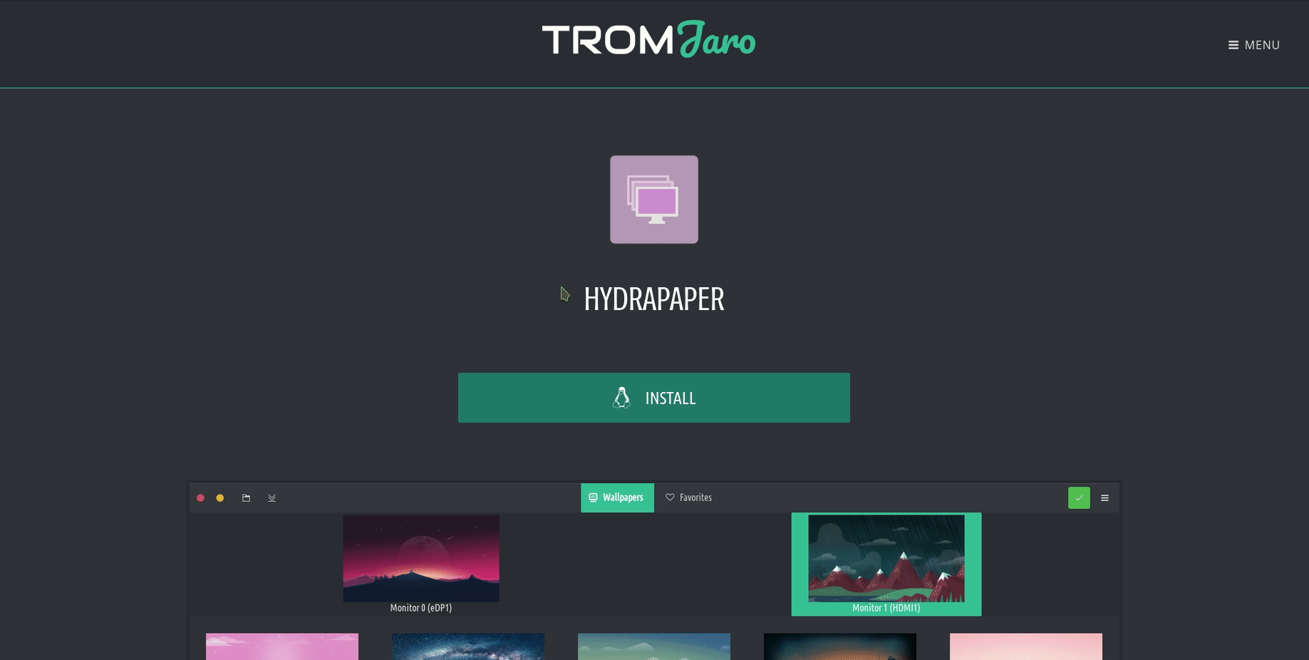

Curated trade-free applications
In TROM-Jaro you can find thousands upon thousands of applications.
Pretty much every single application that is available for Linux is available in Add/Remove Software in TROM-Jaro.
On this page you will find curated trade-free applications (we are adding more and more all the time). The “install” button works by default with TROM-Jaro 01.10.19 and newer.
Categories: Accessories, Graphics, Internet, Office, Science, Sound & Video, System Tools

Latest apps (1)
. | Riot.im
. | Kdenlive
. | Celestia
. | Timeshift | System Tools
. | Firefox | Internet
. | Jitsi Meet
. | KStars
. | Audacity (audio editor)
. | Audio-Recorder
. | ClipGrab
. | Stellarium (software)
. | Ardour (software)

Latest apps (2)
. | Ciano
. | GColor
. | Converseen
. | Copy Paste Grab
. | GIMP
. | HandBrake
. | Imagine
. | Inkscape
. | Kazam
. | Krita
. | Peek (software) | Graphics, Sound & Video
. | Vidcutter

Latest apps (3)
. | youtube-dl-gui
. | Back in Time (Linux software)
. | Déjà Dup | Accessories
. | Ungoogled Chromium
. | FileZilla
. | Signal (software)
. | Mozilla Thunderbird
. | GNOME Boxes
. | Bookworm
. | MyPaint
. | Gnote
. | Heimer

Latest apps (4)
. | LibreOffice
. | Mini Diary
. | gedit
. | Beaker (web browser)
. | Notable
. | FreeTube
. | OnionShare
. | Notes-Up
. | Popcorn Time
. | Eye of MATE
. | Tor (anonymity network)
. | Photo Collage

Latest apps (5)
. | Transmission (BitTorrent client)
. | Cantata (software)
. | Tribler
. | Cozy
. | Deepin Music
. | Waterfox
. | CPod
. | Easystroke
. | Lollipop
. | WebTorrent | Internet
. | MusikWave
. | Gnome Subtitles

Latest apps (6)
. | ANoise
. | Qoob Music Player
. | CopyQ
. | Crow Translate
. | SMPlayer
. | Flameshot | Graphics
. | Ideogram
. | KeePassXC
. | GNOME Maps
. | VLC media player | Sound & Video
. | Mindmapp
. | OBS Studio

Latest apps (7)
. | Raven Reader
. | Shotwell (software)
. | Master PDF Editor
. | Cheese (software) | Sound & Video
. | GNOME Recipes
. | Spice-up
. | Temps
. | Guvcview - GUV
. | GNOME Weather
. | Evince
. | Flat Remix Icons
. | Tela Icons

Latest apps (8)
. | Papirus Icons
. | Paper Icons
. | EvoPop Icons
. | Zafiro Icons
. | Arc Maia Theme
. | EvoPop Theme
. | Matcha Theme
. | Vimix Theme
. | Disk Usage Analyzer
. | GNOME Disks
. | GParted Partition Editor
. | mpv (media player) | Sound & Video

Latest apps (9)
. | GNOME TWEAKS | Accessories
. | Firewall Configuration
. | GNOME Calculator | Accessories
. | Syncthing | Internet
. | Gnome System Monitor
. | mintStick
. | GNOME Calendar | Office
. | TiddlyWiki
. | Abricotine
. | Blender (software)
. | BlueGriffon
. | VirtualBox

Latest apps (10)
. | AutomaThemely
. | DeaDBeeF
. | VeraCrypt
. | bauh
. | Clementine (software)
. | BiglyBT
. | digiKam
. | Drawing
. | Drawpile
. | GNOME Evolution
. | vokoscreenNG - formerly known as vokoscreen
. | Flowblade

Latest apps (11)
. | FeedReader
. | Exaile
. | Deepin Screen Recorder
. | Foliate
. | Font Finder | Accessories
. | GIFCurry
. | OpenShot
. | PDF Arranger
. | Quilter
. | Pencil2D
. | Nextcloud Desktop
. | Pinta (software)

Latest apps (12)
. | RetroShare
. | SimpleScreenRecorder
. | gThumb | Graphics
. | Synfig
. | Tauon Music Box - Music Player
. | Image Burner
. | TeamViewer
. | GNOME To Do
. | Moka Icons
. | Plane Icons
. | Sardi Icons
. | Stilo Theme

Latest apps (13)
. | Shades of Gray Theme
. | Xtreme Download Manager
. | Qogir Theme
. | Flatix Theme
. | Canta Theme
. | Amber Theme
. | Lliurex Cursor
. | Breeze Cursor
. | Bibata Cursor
. | Arch Cursor Complete
. | Maya Cursor
. | Oxygen Cursor

Latest apps (14)
. | Chameleon Cursor
. | Buttercup
. | DotFonts
. | Minder
. | KolourPaint
. | GTKhash | Accessories
. | Green Recorder
. | Manuskript
. | Olivia
. | PDFslicer
. | TrimDown
. | Avidemux

Latest apps (15)
. | Cryptomator
. | krop
. | PDF2PNG
. | Raddiu
. | Apostrophe (text editor) - formerly known as UberWriter
. | Feeds
. | HydraPaper
. | µPad - MicroPad
. | Rhythmbox
. | Subtitle Composer
. | Trimage
. | Typora

Latest apps (16)
. | Mojave Theme
. | Layan Theme
. | Chrome OS Theme
. | cabal.chat
. | SoundRecorder
. | aMule
. | qTox - Tox (protocol) | Internet
. | Marble (software) | Science
. | Parole Media Player | Sound & Video
. | 0 A.D. (video game)
. | Claws Mail
. | Darktable

Latest apps (17)
. | Dat Desktop
. | Deepin Draw
. | Dictionary
. | Fractal
. | GeoGebra
. | Godot (game engine)
. | Jami (software)
. | ImCompressor
. | Pitivi
. | KColorChooser
. | Klotski
. | KMahjongg

Latest apps (18)
. | Lights Off
. | Knights
. | Mines
. | OpenRA
. | Palapeli
. | Elisa
. | Podcasts
. | Polari
. | Patchwork
. | FeatherNotes
. | Rats Search
. | Remmina

Latest apps (19)
. | Shotcut | a free, open source, cross-platform video editor
. | SMTube | Sound & Video - YouTube browser for SMPlayer
. | Spectral | Internet - a glossy native [Matrix] client
. | SuperTux
. | Vinagre
. | uGet
. | Vocal | W.A.I.T. (What Am I Trading?) This app uses iTunes for certain functionalities, which means that Apple may collect data about the users. Users trade their data in order to access the iTunes service.
. | VPaint
. | SuperTux Kart
. | Wings 3D
. | Sound Konverter
. | Spectrum | W.A.I.T. (What Am I Trading?) Since Spectrum is a centralized service, then they can ban/censor content. Thus what you trade is your freedom of expression to their internal rules.

Latest apps (20)
. | Qalculate
. | Knowte
. | KFourInLine
. | Falkon
. | MystiQ
. | GNOME Clocks
. | GNOME Contacts
. | Nibbles (video game)

Reference
Curated Trade-Free Applications

